

1717, Shivaji Nagar, Fourth Floor Zenith Complex, Opposite Krushi Bhavan, Pune-411005 Phone: 9822020999; Email: sales@alfatechindia.com; www.alfatechindia.com.

MILKING MACHINE SPECIFICATION

1.MINI MILKING MACHINE (Cow Only)
- It works on single phase electricity also work on 1000KVA Inverter

- Pressure Gauge and 200 LPM Vacuum Pump ,1 HP Oil Vacuum Pump

- Complete assembled 25 Liter Stainless Steel Milk Can with 25 ft. pipe.

- Milks 8-10 cows in one hour, Can milk 5/6 buffalo per hour

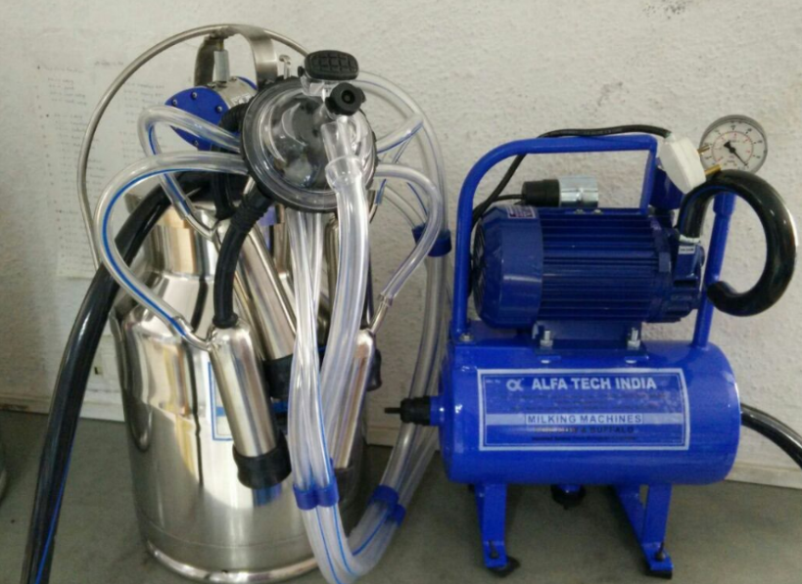

1717, Shivaji Nagar, Fourth Floor Zenith Complex, Opposite Krushi Bhavan, Pune-411005 Phone: 9822020999; Email: sales@alfatechindia.com; www.alfatechindia.com

2.MINI MILKING MACHINE (Buffalo Only)
- It works on single phase electricity.

- Pressure Gauge and 300 LPM,1/2 HP Dry Vacuum Pump

- Complete assembled 20 Liter Stainless Steel Milk Can with 25 ft. pipe.

- Milks 6-7 cows in one hour.

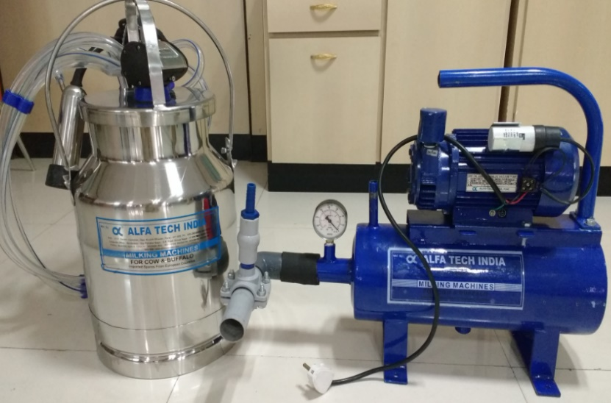

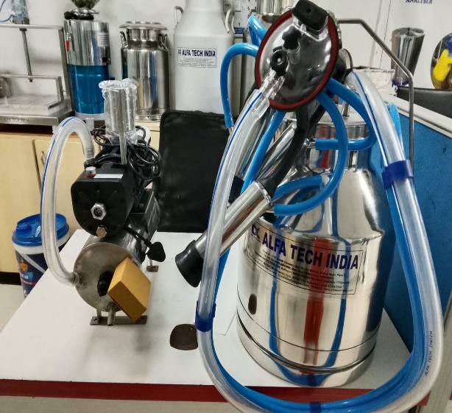
3.SINGLE BUCKET MILKING MACHINE (Cow Only)
- It comprise of Complete Assembled 20 Liter stainless steel Milk Can.

- Pulsator: Milk rhythmically without hurting animal.

- Orbitor: Liners, one milking tube and vacuum tube are attached, this is also important part of machine.
- Pressure Gauge: Which shows how much pressure should be applied
for animal.

- Can Gasket: Which will assure that can is perfectly fixed.

- 150 LPM Vacuum Pump and single phase electricity supply.

- Standard ½ HP motor is used.

- Honda Engine: This is optional if you are facing problem of Electricity,
then we have made arrangement to attach 1.5 HP Honda Engine, which
work smoothly 2-2½ hours on 1 liter of kerosene or diesel.

- Milks 10-12 cows in one hour.

1717, Shivaji Nagar, Fourth Floor Zenith Complex, Opposite Krushi Bhavan, Pune-411005 Phone: 9822020999; Email: sales@alfatechindia.com; www.alfatechindia.com
4.SINGLE BUCKET MILKING MACHINE(COW/BUFFALO)
- It comprise of Complete Assembled 20 Liter stainless steel Milk Can.
- Pulsator: Milk rhythmically without hurting animal.

- Orbitor: Liners, one milking tube and vacuum tube are attached, this is also important part of machine.
- Pressure Gauge: Which shows how much pressure should be applied for animal.

- Can Gasket: Which will assure that can is perfectly fixed.

- 300 LPM Vacuum Pump and single phase electricity supply.

- Standard 1½ HP motor is used.

- Honda Engine: This is optional if you are facing problem of Electricity, then we have made arrangement to attach 1.5 HP Honda Engine, which work smoothly 2-2½ hours on 1 liter of kerosene or diesel.

- Milks 10-12 Cows & 8-10 Buffalo in one hour.
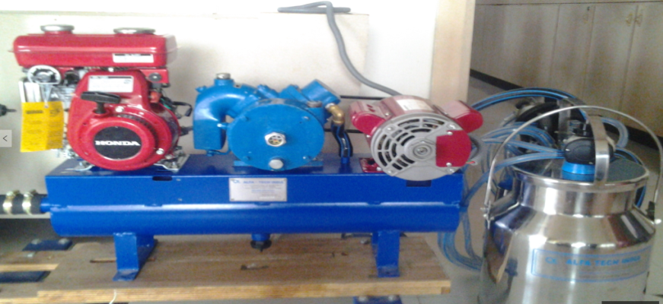

1717, Shivaji Nagar, Fourth Floor Zenith Complex, Opposite Krushi Bhavan, Pune-411005 Phone: 9822020999; Email: sales@alfatechindia.com; www.alfatechindia.com
5.DOUBLE BUCKET MILKING MACHINE
- It comprise of Complete Assembled Two 20 Liter stainless steel Milk Can.

- Pulsator: Milk rhythmically without hurting animal.

- Orbitor: Liners, one milking tube and vacuum tube are attached, this is also important part of machine.
- Pressure Gauge: Which shows how much pressure should be applied for animal.

- Can Gasket: Which will assure that can is perfectly fixed.

- 300 LPM Vacuum Pump and single phase electricity supply.

- Standard 1 HP motor is used.

- Honda Engine: This is optional if you are facing problem of Electricity, then we have made arrangement to attach 1.5 HP Honda Engine, which work smoothly 2-2½ hours on 1 liter of kerosene or diesel.

- Milks 20-25 cows & 15-20 Buffalo in one hour.
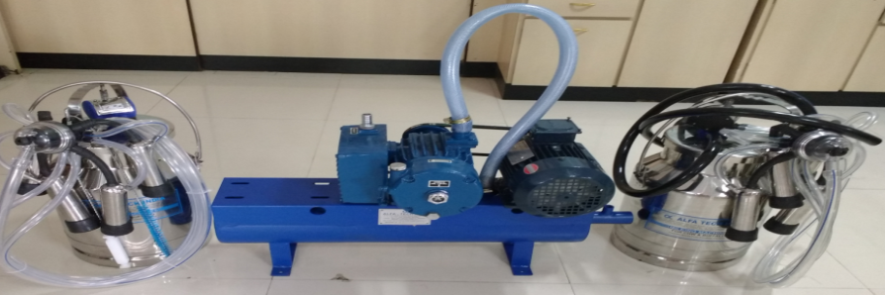

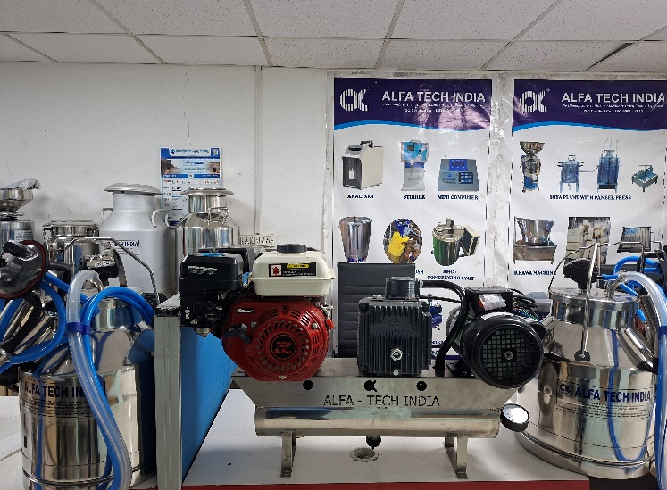

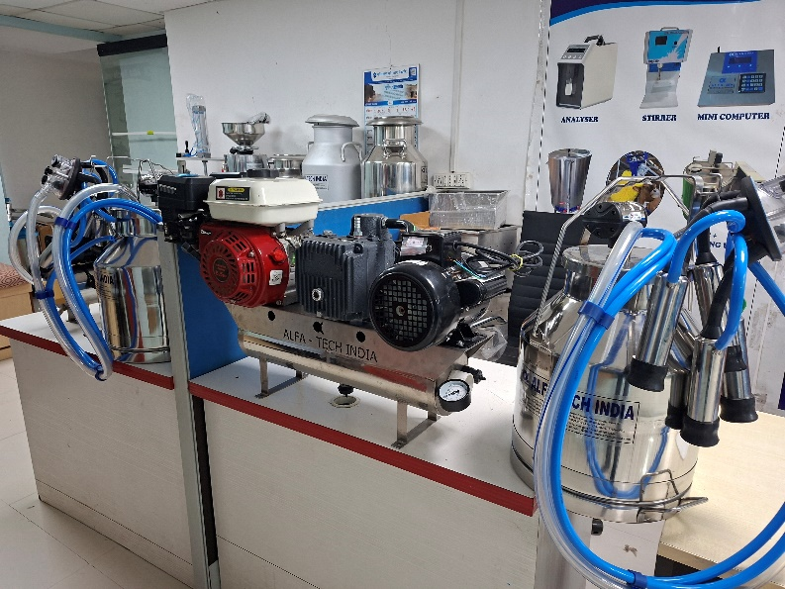

6. Three Bucket Milking Machine(Buffalo/Cow)
- It comprise of Complete Assembled Three 20 Liter stainless steel Milk Can.

- Pulsator: Milk rhythmically without hurting animal.

- Orbitor: Liners, one milking tube and vacuum tube are attached, this is also important part of machine.
- Pressure Gauge: Which shows how much pressure should be applied for animal.

- Can Gasket: Which will assure that can is perfectly fixed.

- 600 LPM Vacuum Pump and three phase electricity supply.

- Standard 2 HP motor is used.

- Milks 35-40 cows & 30-35 Buffalo in one hour.

1717, Shivaji Nagar, Fourth Floor Zenith Complex, Opposite Krushi Bhavan, Pune-411005 Phone: 9822020999; Email: sales@alfatechindia.com; www.alfatechindia.com
7. Four Bucket Milking Machine(Buffalo/Cow)
- It comprise of Complete Assembled Four 20 Liter stainless steel Milk Can.

- Pulsator: Milk rhythmically without hurting animal.

- Orbitor: Liners, one milking tube and vacuum tube are attached, this is also important part of machine.
- Pressure Gauge: Which shows how much pressure should be applied for animal.

- Can Gasket: Which will assure that can is perfectly fixed.

- 600 LPM Vacuum Pump and three phase electricity supply.

- Standard 2 HP motor is used.

- Milks 45-50 cows & 40-50 Buffalo in one hour.

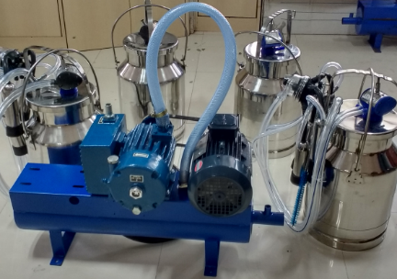

Trolly Milking Machine:

Milking machine
Single Bucket (Trolley model)
Motor : 1HP Single phase
Vacuum Pump : 200LPM (Pressue Guage, Regulator)
Can with Assembly - 1 (Pulsator, Claw,Liner Set, Shells,Milk tube)
Material : Stainless Steel
Can Capacity : 25 L
Vacuum Pipe : 20 Feets
Food grade material pipes
Works on : Electricity & Invertor

